**Developers Manuel -Meteor Beat**

Developed using Unity 2019.1.14

You can download it here -> <https://unity3d.com/get-unity/download/archive>

In collaboration with GitHub and Discord for multiuser productivity

**Context Diagram**

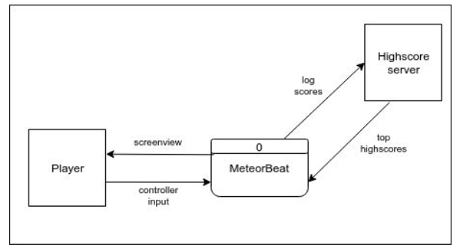

**Class Diagrams**

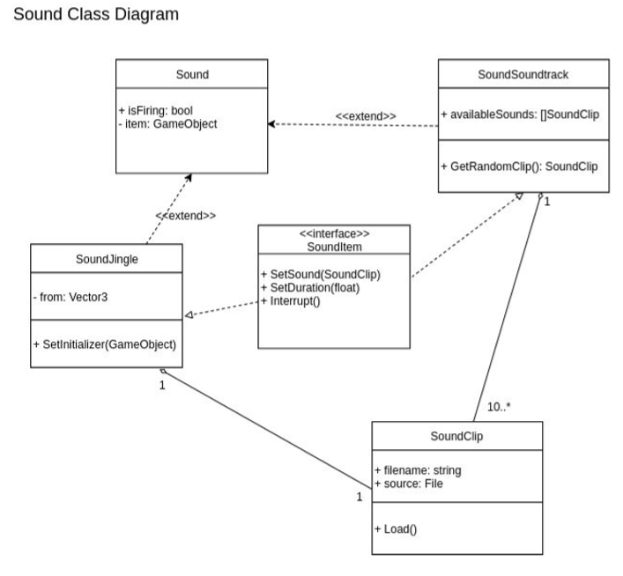

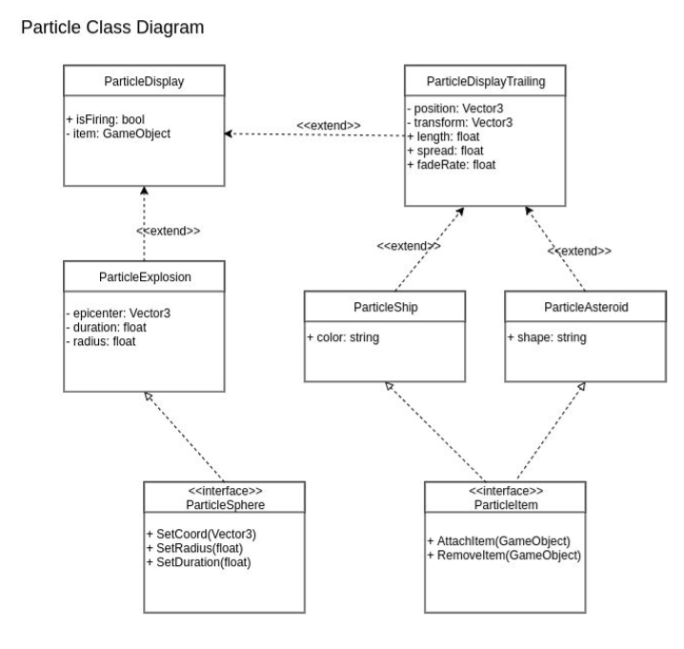

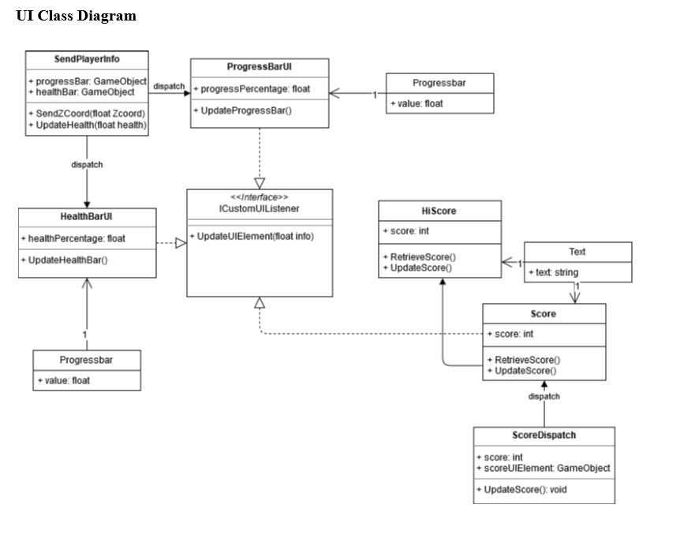



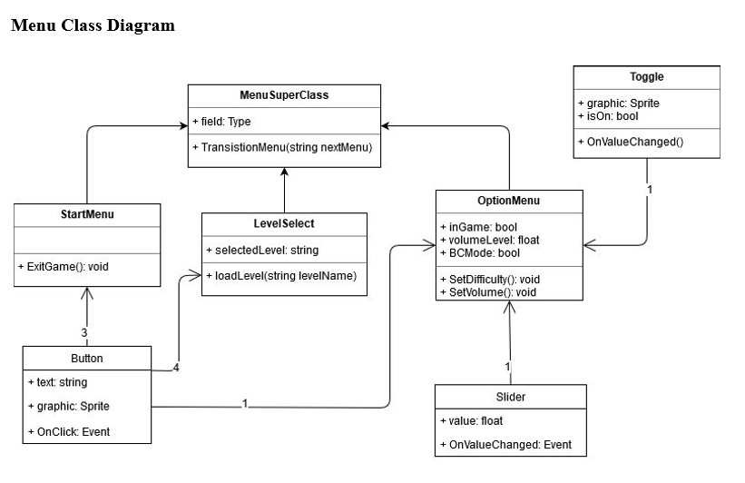**Particles Class Diagram**

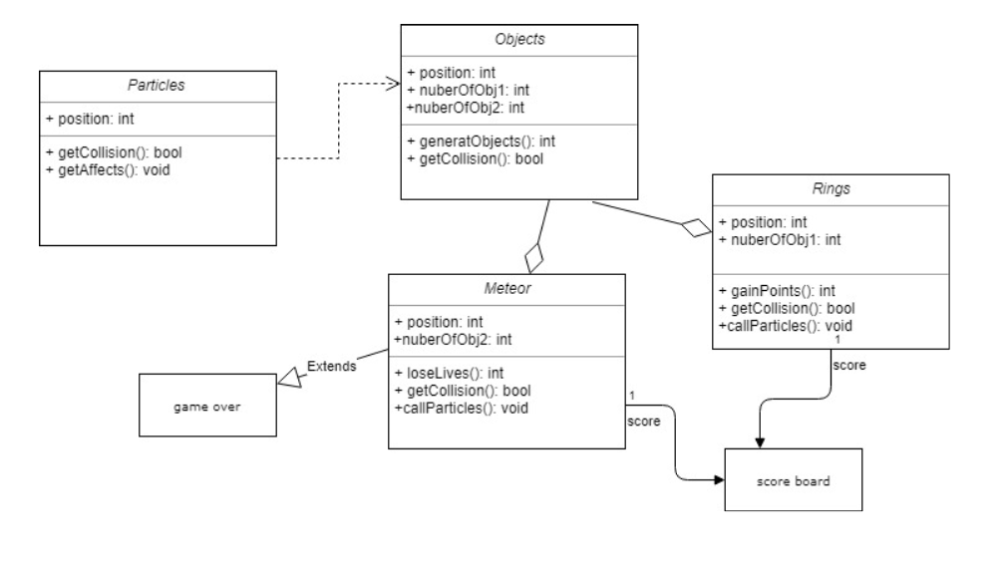

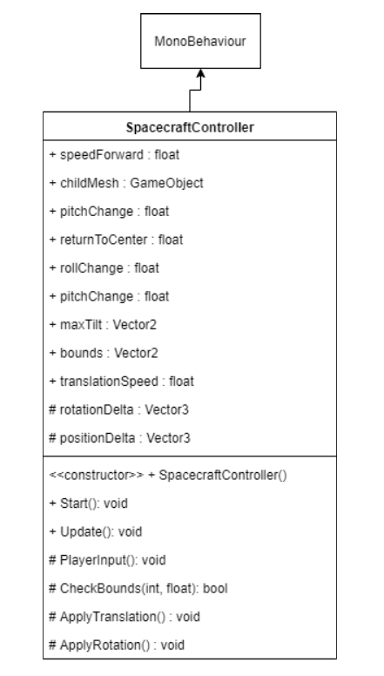**Controls Class Diagram**